ASSIGNMENT 2

TEAM ID: PNT2022TMID04321

Student name: S. Harisudhan

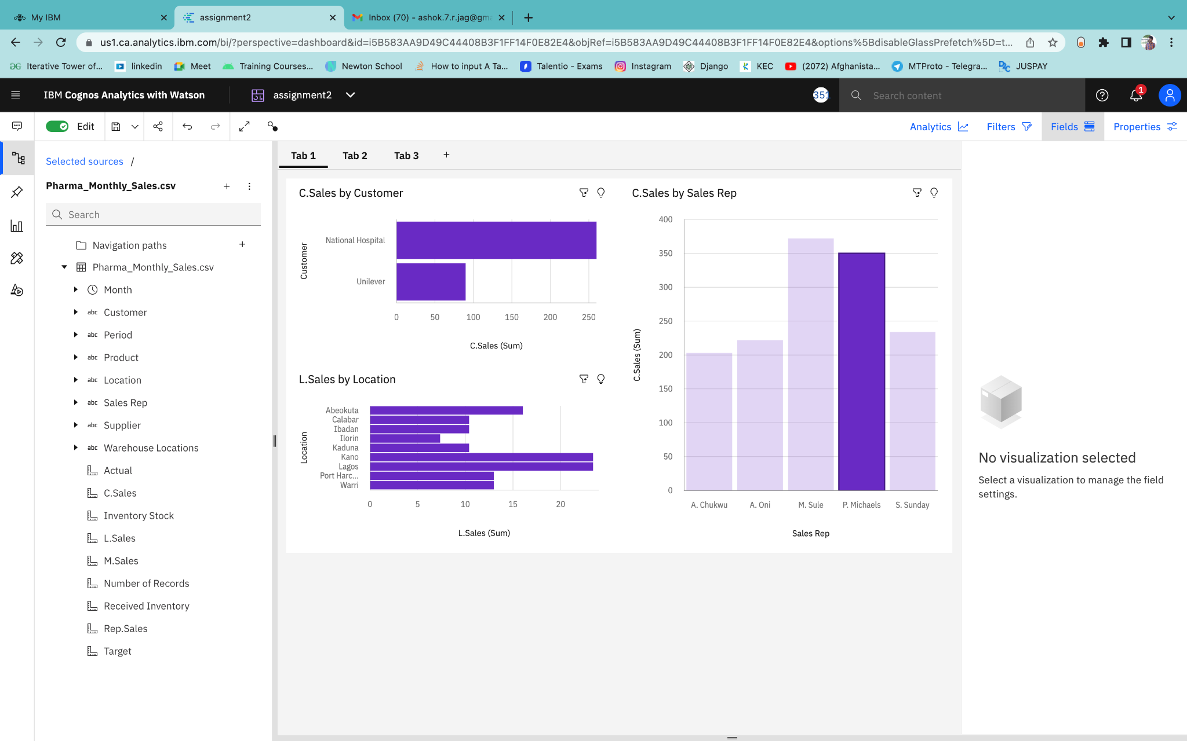

<https://us1.ca.analytics.ibm.com/bi/?perspective=dashboard&pathRef=.my_folders%2FAssignment_2%2Fassignment2&action=view&mode=dashboard&subView=model000001838d12b70c_00000000>

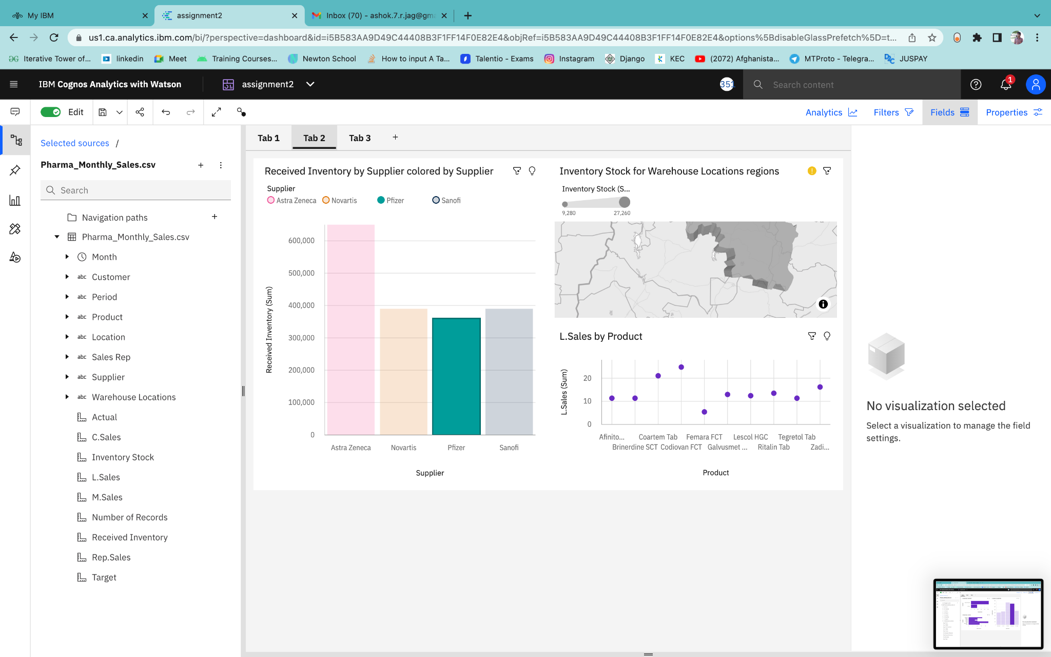

<https://us1.ca.analytics.ibm.com/bi/?perspective=dashboard&pathRef=.my_folders%2FAssignment_2%2Fassignment2&action=view&mode=dashboard&subView=model000001838d12b70c_00000000>

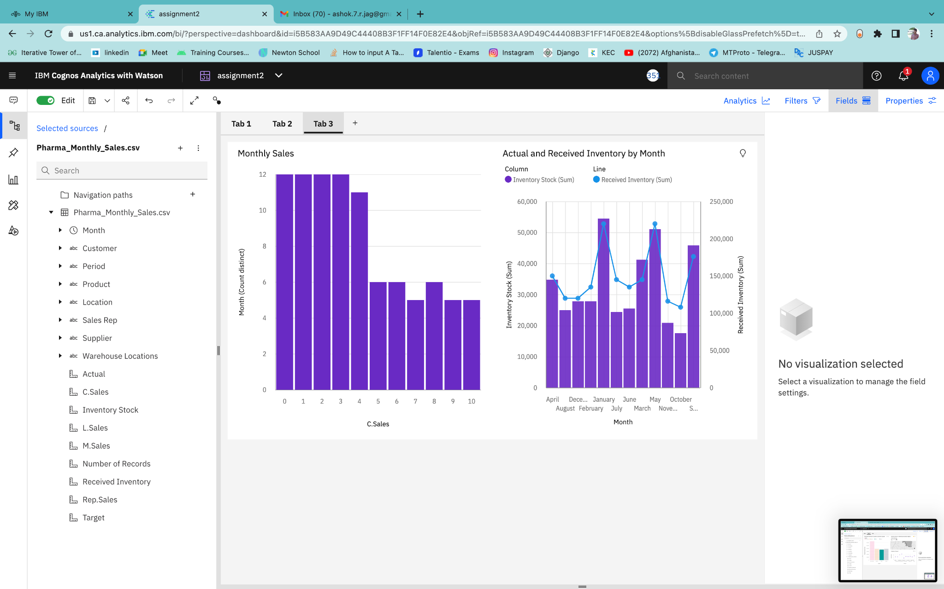

<https://us1.ca.analytics.ibm.com/bi/?perspective=dashboard&pathRef=.my_folders%2FAssignment_2%2Fassignment2&action=view&mode=dashboard&subView=model000001838d12b70c_00000000>